I need to take one of the mechanics and prototype it
I can use asset store assets

NOT SURE IF 2D OR 3D WOULD BE BETTER
==
Sort toys into the correct categories
- Backdrop GROTTO/ ELVES
- Sound Design
- Lighting Design (Christmas lights)
- UI List of what shape toys go Ito what sack
- Gamification (Line goes faster, broken toy?, Timer)
- SFX On the

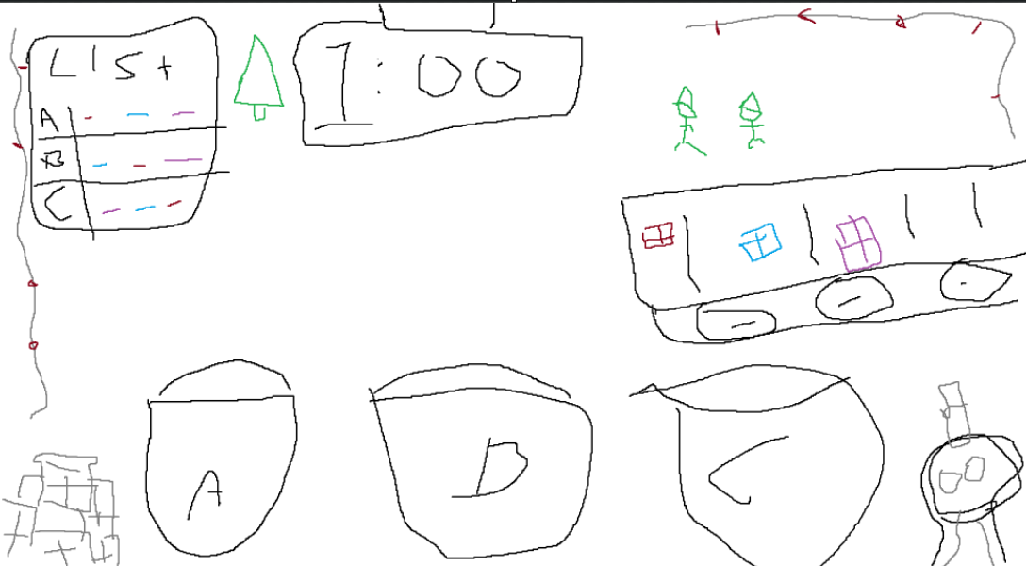

If more time – Wrap presents (But this would be before)

